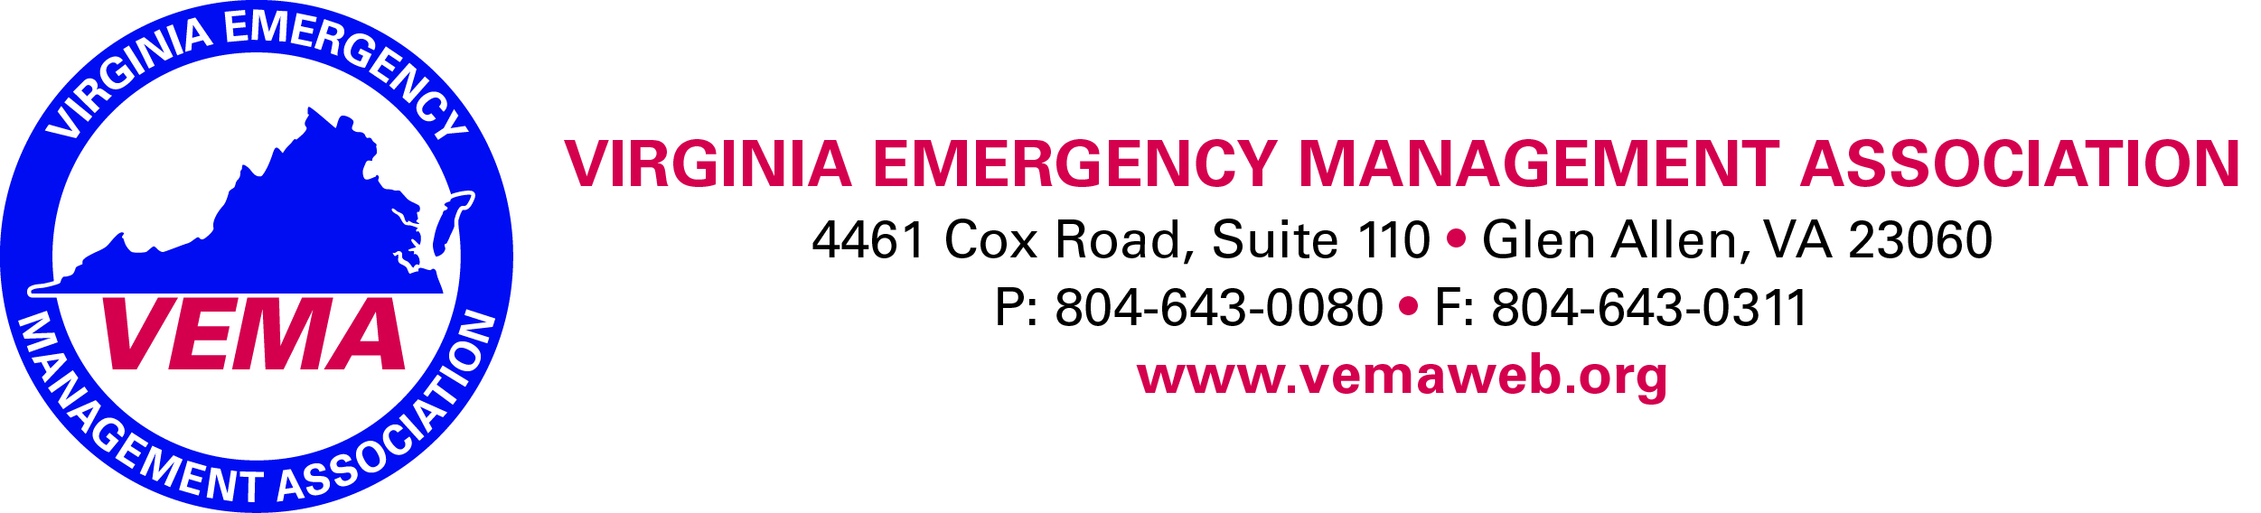

Executive Board Conference Call - October 26, 2017

The meeting was called to order at 1:02 pm by Walter English who presided. In attendance were VEMA Board members Robert Foresman, Creig Moore, Jennifer Maul, Walter English, Bill Lawson, and Bo Keeney (Executive Director).
Under New Business the following items were discussed by the VEMA Executive Board.
- VEMA Fall Forum Review
  - Working on a better sponsor/vendor packet for the 2018 Fall Forum program
  - Should solicit companies/businesses in the fall of 2017 for 2018 Fall Forum so that it can be incorporated into their budgets appropriately.
  - Suggest increasing funding for fall forum in 2018 in the budget process
- Certification review at symposium
  - Examine the possiblity of some incentive program for people who submit certifications at the annual conference. Executive Board suggest a 15% discount off the certification fee.
- Discounted rate to join - membership drive
  - The membership committee is going to come to the board with a proposal for a membership recruitment drive in the coming months.

Under Old Business the following items were discussed by the VEMA Executive Board
  - Health Care Caucus (See attached document). This will be presented to the full board of directors at the next meeting. The executive committee has noted that any new causus must have appropriate leadership to drive a caucus from within.

President Update
  - Stragetic plan update
    - Starting process for updating strategic plan. Each chair will be responsible for completing a portion of the strategic plan review and update.

1st VP – Symposium
  - 2 Items – Registration opening November 1 rather than October 1 since VDEM had not notified all speakers. This will allow us to have sessions names/descriptions on website.
  - Rick Opett is still examining the possiblity of putting together a golf tournament pending a sizeable sponsorship to offset the pricing.
  - Worked with the networking committee to establish a location for everyone to gather upon arriving on Tuesday of the conference.

There being no further business the meeting was adjourned at 1:24 pm

Respectfully Submitted,

Creig Moore, Secretary

