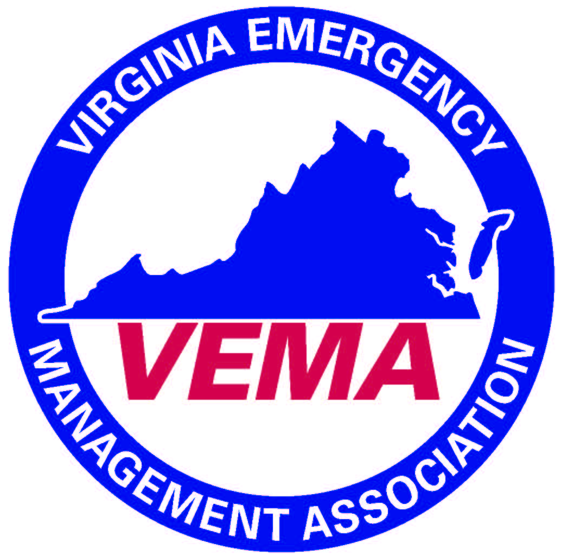
VEMA 2019 Annual Business Meeting Minutes
The meeting was called to order at 12:16 pm by Walter English who presided. In attendance were 115 VEMA members. At the head table were the following individuals: Bo Keeney (Executive Director), Walter English (President), Robert Foresman (1st VP), Jennifer Maul (2nd VP), Bill Lawson (Treasurer) and Michelle Oblinsky (Past President).

Walter English (VEMA President) welcomed the membership and began with his report; noting the successes and growth of VEMA over the last year. He thanked the VEMA Board of Directors, the Executive Board and the Keeney Group staff for their guidance and help over the last year.
A special presentation was offered by the VEMA Annual Business meeting sponsors (Everbridge).
Under a special order of business, Michelle Oblinsky was awarded her past president’s plaque.
Michelle Oblinsky was called to the stage to present the slate of candidates for the 2019 elections which included the following individuals:
  - Candidate for President: Robert Foresman Candidates for 1st VP: Jennifer Maul
  - Candidates for 2nd VP: Sherri Laffoon Candidate for Secretary: Robert Gelormine
  - Candidate for Treasurer: William Flagler

Robert Foreman, Jennifer Maul, Robert Gelormine and William Flagler were all elected by acclimation. Bill Lawson was nominated from the floor by Scott Hudson for the position of 2nd VP, the nomination from the floor was seconded by Neal Turner. A ballot vote was conducted in accordance with the VEMA constitution and bylaws. The winner of the election would be announced at the conclusion of the meeting.

Under the Secretary’s report Jennifer Maul moved to accept the minutes of the March 2018 Annual Membership Meeting as distributed. The motion was seconded by Neal Turner. The motion passed unanimously.
Under the Treasurer’s Report Bill Lawson presented a financial overview of the VEMA finances which included the following:
  - Report on the VEMA financial position (As of Feb 29, 2019)
    - Checking Account $203,423.31
    - Money Market Account $49,304.41
    - CD’s totaling $66,996.35
    - Audits of books on a monthly basis continue to show we’re in a solid financial position and the books are in good condition.

Motion by Bill Lawson to approve the VEMA financial summary of accounts as presented. The motion was seconded by Scott Hudsona. The motion passed unanimously.

Bo Keeney (VEMA Executive Director) presented the Executive Director’s report in which he commented on the VEMA membership numbers, highlighting the overall growth in the past year. He additionally reviewed various member benefits that VEMA members could utilize, VEMA finances and the continued success of the VEMA symposium. Finally he reviewed some of the VEMA activities and offerings during the past year which included:
Re-established quarterly VEMA newsletter, Conducted a 2019 Legislative Lobby Day, Advocated (lobbied) for the profession before the Virginia General Assembly, 20+ hours of VEMA Board and Executive Board meetings
350+ hours of VEMA committee work, Held multiple “Brown Bag” Townhall with Dr. Jeff Stern, Conducted EMPG & LEMPG surveys, VEMA Scholarships (Addison Slayton, Grace Tressler, Gordon Barwell), VEMA Certifications (PEM/AEM)
VEMA Classified Job Board – over 75 jobs posted during 2018-2019, “VEMA Voice” E-Blast, VEMA Participated in trade shows of 5+ organizations promoting VEMA and your benefits, Offered records of VEMS general sessions, VEMA Silent Auction, VEMA Golf Tournament, Updated the VEMA Strategic Plan, Redesigned Online VEMA Store, VEMA Board of Directors Monthly “Board Briefs”, VEMA audit committee , Approved new anti-trust, conflict of interest, document destruction, and whistleblower policies.
Lastly he presented an overview of the new VEMA strategic plan to the entire membership and encouraged members to get involved.

The following committee reports were presented:
  - Legislative Committee (Hui-Shan Walker & Rob Bohannon – VEMA lobbyist)
    - They presented an overview of the 2019 VEMA legislative session, how to become involved in future endeavors and what may be on the horizon for future legislative years.
  - Audit Committee (Jennifer Maul)
    - The committee continues to audit the VEMA books on a monthly basis and everything appears to be in good fiscal condition. The Keeney Group continues to do a very good job handling the VEMA finances.
  - Membership & Marketing Committee (Sherri Laffoon)
    - The committee presented an overview of membership recruitment and retention programs that they’ve offered over the last year. Additionally the committee hopes to expand the number of committee members in the future.
  - Constitution / By-Laws Committee (Jeff Fletcher)
    - The committee has been working hard on the proposed VEMA bylaws amendments that will be presented under new business.

Under New Business the following were presented.

Honorary membership was awarded Jim Davis for his outstanding service and dedication to VEMA throughout their career.

The following bylaws changes were presented by the VEMA bylaws committee and endorsed by the VEMA Board of Directors:

VEMA Constitution Proposed change #1: Article 4 Officers; Section 5 Vacancies
(b) Should a vacancy occur in any office other than President, a successor may be nominated and elected by the Executive Committee to fill the vacancy for the unexpired term of office. Such nominees need not be members of the Executive Committee or Board of Directors to be selected however, persons nominated must be an Association member who has met meet all membership, officer, and fee requirements set forth in the Association By-Laws.

VEMA By-Laws change #2: Article 1 Membership; Section 1 General
(e)…Regular Individual Membership…

VEMA By-Laws change #3: Article 1 Membership; Section 2 Membership Categories
(a) Regular Individual Membership
Regular Individual Membership is open to any individual whose interest or responsibilities relate to emergency management. This membership allows those interested in serving the Association the opportunity to seek membership as a Board of Directors member, on committees and/or run for office. Every member in this category is entitled to vote in all elections and for other matters brought before the membership.

(c) Honorary
The President and the Board of Directors at its discretion and by its vote, may award to any person displaying outstanding contributions to the Association and /or its purposes an Honorary Membership. The person receiving Honorary Membership is regarded as an Associate Member for the lifetime of said person. Honorary Members shall not be required to pay Association dues and cannot vote in elections or on matters brought before the membership. They may be appointed to committees in an advisory capacity only and cannot run for office. Any active member may submit to the President and Board of Directors recommendations for Honorary Membership.

The President and the Board of Directors, at their discretion and by its simple majority vote, may award Honorary membership to any person who has made contributions to the Association that are considered above and beyond and exceed the values and mission of the Association. Any active or past member may submit recommendations to the President and Board of Directors for Honorary Membership.

The person receiving the Honorary membership is regarded as a lifetime Associate Member. Honorary Members shall not be required to pay Association dues and do not have voting rights. Honorary Members may be appointed to committees in an advisory capacity only but may not be nominated for or elected to any office.

(h) Lifetime
The President and the Board of Directors, at their discretion and by its simple majority vote, may award Lifetime membership to any member who is leaving the emergency management field or the Commonwealth of Virginia and who has actively participated in Association committee or other notable work for a minimum of ten (10) years. Their contributions are considered above and beyond and exceed the values and mission of the Association. Any active or past member may submit recommendations to the President and Board of Directors for Lifetime Membership.

Lifetime Members shall not be required to pay Association dues and do not have voting rights. Lifetime Members may be appointed to committees in an advisory capacity only but may not be nominated for or elected to any office.

VEMA By-Laws change #4: Article 2 Officers
Article 2 Elected and Appointed Officers

Section 1. Qualifications
- To be elected or appointed to office, a member shall meet the following requirements:
  - Have been either an Individual Member or voting member of a state agency or organizational membership for a minimum of two (2) complete, consecutive years prior to seeking officer.
  - Served as a committee chair or an active member of a VEMA Caucus or the Board for two (2) complete, consecutive years.

Section 1 3 Duties

VEMA By-Laws change #5: Article 10 Amendment of By-Laws
…and the full Association regular membership members are notified…

The motion to approve the VEMA bylaws changes was passed unanimously.

Walter English (VEMA President) asked if there were any other issues to come before the membership. There being none Michelle Oblinsky was invited back to the stage to announce the winner of the VEMA 2nd VP position. The committee announced that Sherri Laffoon has been elected to the office of VEMA 2nd VP by ballot vote.

There being no further business the meeting was adjourned at 1:18 pm

Respectfully Submitted

Bo Keeney on behalf of VEMA Secretary Creig Moore.

