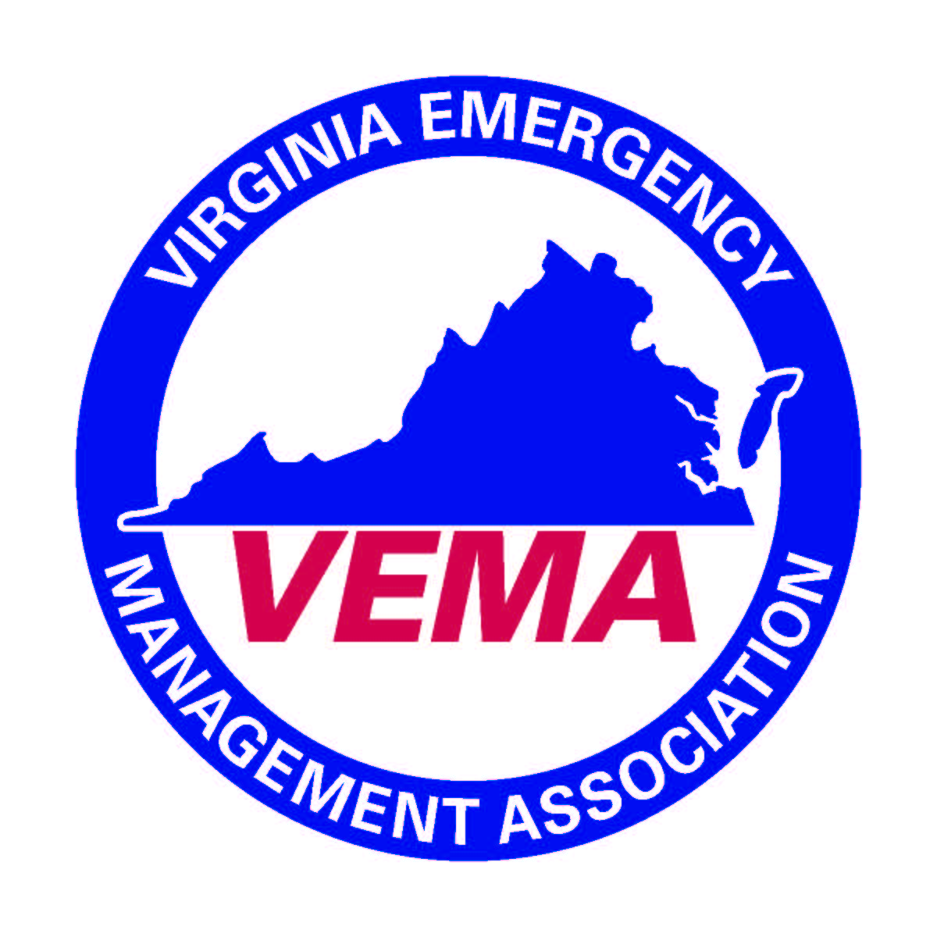
Executive Board Conference Call
6/22/2016

In attendance were Michelle Oblinsky, Robert Foresman, Walter English, Jennifer Maul and Sara Ruch

The meeting was called to order by Michelle Oblinsky at 3:00 pm. She presided over the meeting after reminder all board members of the VEMA conflict of interest and anti-trust policies.

AGENDA:
- Audit Recommendations (Robert & Jennifer)
  - The board discussed the proposed guidelines for the audit committee. There were variety of questions concerning the proposed guidelines. The group discussed how to conform guidelines so that they are in alignment with the Keeney Group management contract. The full revised proposed guidelines will be sent out ASAP.
- Global Momentum Proposal (Michelle)
  - Web services (offered by the Olson Group) that searches the web and compiles it into one place. (automated clipping service). Discussion of how to offer it to VEMA members. VEMA has discussed with the Olson group discounted pricing for VEMA members. It was discussed whether or not the VEMA should entertain a presentation on these services. (August preferred).
- Keeney Group Evaluation (Michelle)
  - Evaluation has been out via survey monkey for responses. Michelle urged all executive board members to complete the
- August Board Meeting Agenda (Michelle)
  - Request for agenda items to be sent to Michelle ASAP! Tasking agreement, final VEMS report, final 2015-2016 fiscal year report, presentation from Global Momentum Proposal, the strategic communications committee, etc.

Michelle has accepted a position with VDEM and will start in July. New role should not affect her role with VEMA. Congratulations to Michelle!

There being no further business the meeting was adjourned at 3:57 pm.

Respectfully Submitted,

Bo Keeney, Executive Director on behalf of Cheryl Elliott, VEMA Secretary.

