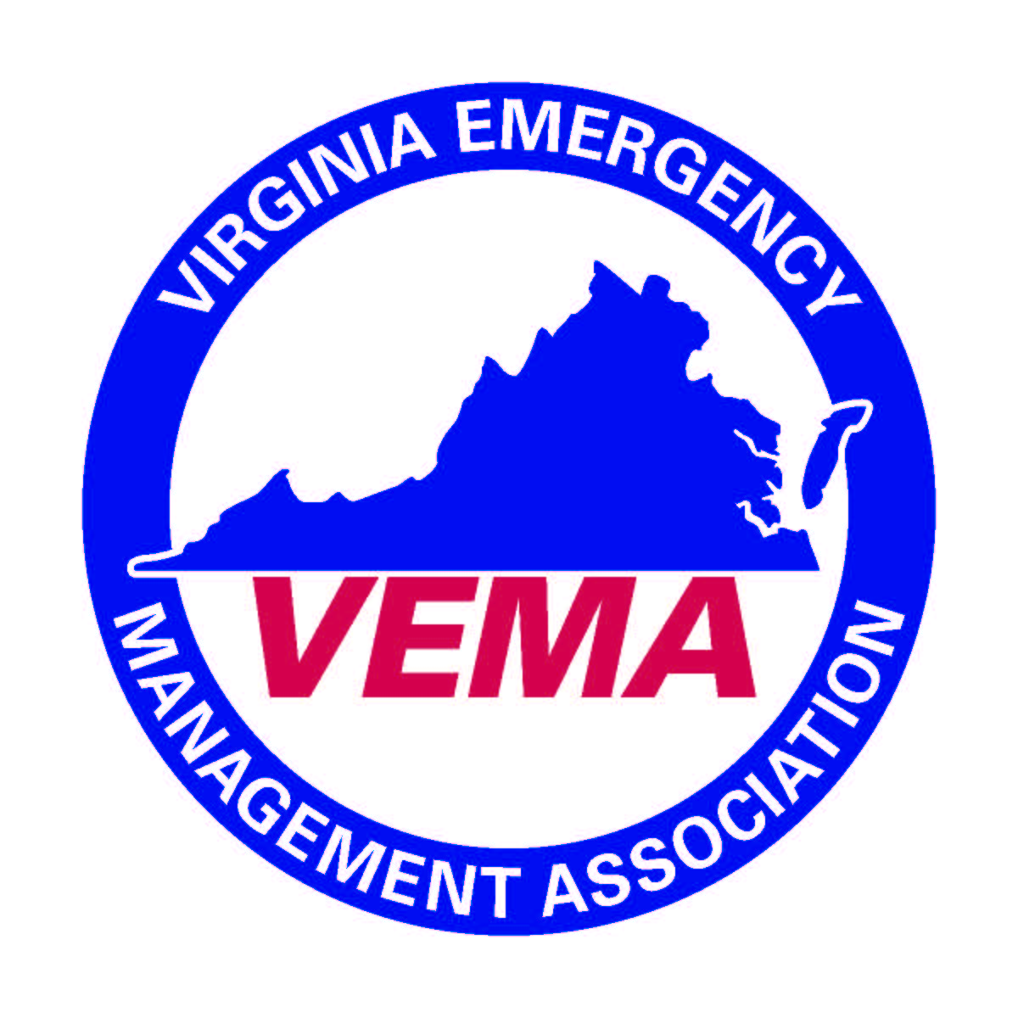**MINUTES VEMA BOARD OF DIRECTORS MEETING (5-18-16)**

Minutes of the Virginia Emergency Management Association (VEMA) held on May 18, 2016 at the VDEM trade court facility in Chesterfield, VA. The meeting was called to order by Michelle Oblinsky, President, at 10:02 am. The following individuals were in attendance: Michelle Oblinsky, Walter English, Robert Foresman, Jennifer Maul, Cheryl Elliott, Benjamin Rupert, Sara Makely, Jeff Hensley, Kirby Felts, George Glazner, Creig Moore, Neal Turner, Dustin Campbell, Will Flagler, Jeff Fletcher, Michael Mulhare, Sherri Laffoon, Brittany Schaal, James Keck, Terrance McGregor, Keith Dowler, Adam Crowe, and Allyson Kuriger. Bo Keeney, Executive Director conducted a roll call and then reviewed the VEMA anti-trust and conflict of interest policies.

Michelle Oblinsky presented the president’s report in which she commented that she represents VEMA on the Emergency Management committee of the Governor’s EMS Advisory Board. She noted that the committee has recently been discussing patient tracking and triage data and information. Updates will be provided to the board once she has something in writing. Michelle asked that, in the interest of time, the board dispense with committee reports and regional committee reports so that there would be enough time for the VEMA Board retreat.

Under the 1st Vice President’s Report, Walter English commented on future VEMS locations. Additionally, he noted that the committee would continue to examine pre-symposium networking sessions such as golf tournaments and wine tasting events. He encouraged the board to pursue additional student involvement as they had done this year. The planning for the fall forum is well underway and the goal is to make it a “mini” symposium.

Under the 2nd Vice President’s report, Robert Foresman commented that the audit committee continues to examine the VEMA books on a monthly basis and continues to find no problems/issues with the management of VEMA funds.

Under the Treasurer’s report, Jennifer Maul moved the following in a block:

1. to approve the VEMA Financial Summary of Accounts as of April 30, 2016 as distributed.
2. to approve the VEMA Financial Statement as of April 30, 2016 as distributed.
3. to accept the final VEMS financial report, showing a net profit of $48,827.40

Motions in a block passed unanimously

Under the Secretary’s Report, Cheryl Elliott moved the following in a block:

1. to accept the VEMA Board of Directors minutes from the February 10, 2016 meeting as previously distributed.
2. to accept the VEMA Executive Board minutes from the April 27, 2016 meeting as previously distributed.
3. to accept the draft VEMA annual membership meeting minutes and to present them to the membership for their approval at the 2017 annual membership meeting.
4. to accept the following as members of VEMA since February 2016:

**Individual Members:**



* **Student Members:**



Motions in a block passed unanimously

Under the Executive Director’s Report, Bo Keeney presented on general membership issues, including the implementation of the new association management system (AMS). He noted that the new AMS system is continually gaining more participation and the staff should be able to derive some metrics in the near future. He asked the Board to review the strategic communications policy so that VEMA could utilize the new AMS to the best of their ability to communicate with members. Furthermore, he provided a review of comments from VEMS 2016 so that the board is fully aware of both positive and negative feedback from the event. As requested Bo presented a list of hotels and/or convention sites that had submitted bids for the 2019 Virginia Emergency Management Symposium. He made the board aware that there were several properties that were not willing to bid on the business but there were still a few strong bids. He suggested that VEMA entertain moving forward with a two-year contract for VEMS 2019 and 2021 with the Newport News Marriott in Newport News, VA. Finally, he informed the VEMA Board that the memorandum of understanding with Columbia Southern has now been fully executed and is in place, as requested.

Committee Reports and Regional Committee Reports were postponed at the request of the President.

Under Caucus Reports, the Institutions of Higher Education presented an overview of their recent activities. Moreover, they informed the VEMA board that the IHE was looking at partnering with VDEM to engage higher education institutions. This will hopefully increase membership and overall involvement of higher education institutions.

There was no old business to be presented.

Under New Business, the VEMA Board discussed the uses of the VEMA listserv, the site for the 2019 VEMS, the possibility of a VEMA online store, and information regarding an external review of the VEMA books.

* 1. Motion Maul/Fletcher for VEMA to proceed with negotiations with the Newport News Marriott for contacts for VEMS 2019 and 2021 pending favorable negotiations. Motion passed unanimously.
  2. Motion Maul/Foresman to approve the VEMA 2016-2017 general fund budget as revised (see notes below) and to use such as a guide for the operation of VEMA during the 2016-2017 fiscal year. Motion passed unanimously. The board did ask that the approved budget and monthly financials be posted to the VEMA members only section of the website.
     1. Line 36 increased from $1000 to $1250 to allow for purchase of shirts for Board members assisting with the 2017 Symposium.
     2. Line 54 increased from $0 to $250 for certification to provide lunches to committee members at planning / application review meetings .
     3. Line 55 increased from $1000 to $2500 for Institute of Higher Education Caucus to conduct regional meetings to encourage participation in the caucus.
     4. Line 81 increased from $4000 to $6000 for Fall Forums. Monies will be used for networking event and speaker fees / honorarium (if needed).
     5. Line 83 decreased transfer to reserves from $7,250 to $3,250 in order to provide a balanced budget.
  3. Additionally the group decided by general consensus to move forward with the creation and operation of a VEMA online store. Neal Turner, Kirby Felts, Robert Foresman and Jennifer Maul were asked to help with the implementation.

There being no further business the meeting was adjourned at 11:39 pm.

Respectfully Submitted,

Cheryl J. Elliott, VEMA Secretary