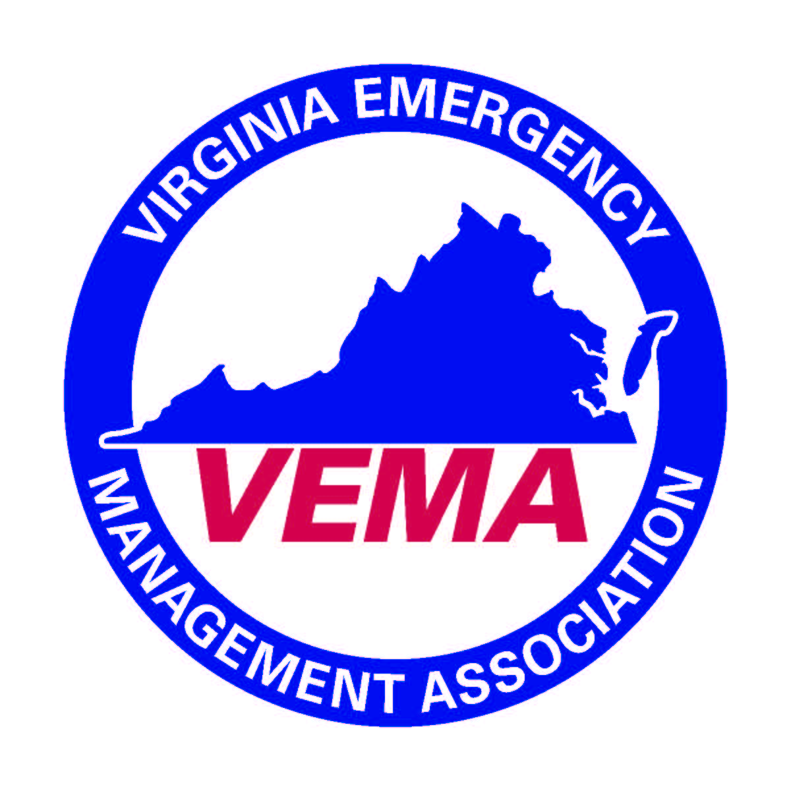

VEMA EXECUTIVE BOARD CONFERENCE CALL – 4/27/2016
In attendance were Michelle Oblinsky, Bo Keeney, Walter English, Cheryl Elliott, and Jennifer Maul. The meeting was called to order by Michelle Oblinsky at 2:04 pm.
Michelle discussed the agenda for the upcoming May 2018 Board meeting. The following items are to be included as discussion or new business items:
Board meeting
· Begin budget discussion – Want to brainstorm ideas in afternoon session to help committee chairs build budget
· Symposium recap
· Fall forum planning
· Determine what we want from the independent review of books

The executive board discussed the upcoming board retreat. Bo was asked to help facilitate the meeting and to keep everyone on target. The retreat should engage committee members to create an actionable plan with a concrete timeline so that the committees may respond back to the board with their results. The retreat will focus on reviewing the strategic plan and then examining the following issues:

Retreat – Building on Strategic Plan that was approved last year; divide into smaller groups to discuss tasks to support the goals and objectives in the plan – things that can be “assigned” to or done at the committee level
· Audit –
· Awards / scholarships – can we do a better job advertising? How?
· Certification Committee – building out mentor committee, changes to certification (are they needed?)
· Constitution and Bylaws – anything new? Any needs for change?
· Legislative Committee – process, feedback session at fall forums, etc.
· Membership & Marketing – newsletter, conference booths, other efforts?
· Nominations –
· Symposium
· Technology
· Regional Reps – discuss responsibilities / expectations
· Other items – idea of holding board meetings in other areas of state at least once a year.

There being no further business the meeting was adjourned at 2:40 pm.

Respectfully Submitted,

Cheryl J. Elliott, Secretary

