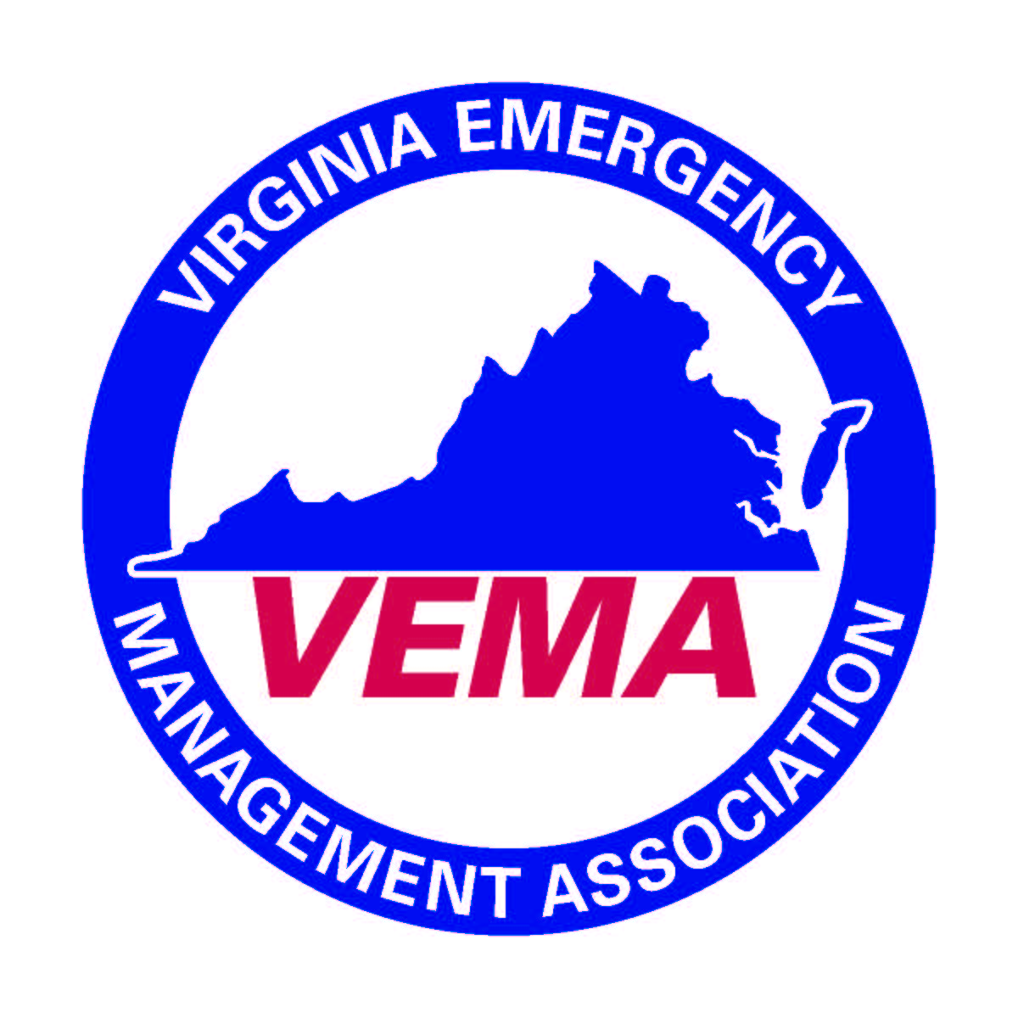
VEMA Executive Committee Conference Call
7/20/2016

In attendance were Michelle Oblinsky, Robert Foresman, Jennifer Maul, Cheryl Elliott, Walter English, Sara Ruch and Bo Keeney.

The meeting was called to order at 10:40 am by Michelle Oblinsky who presided.

Discussion focused around the VEMA newsletter and the future of VEMA communications. The Executive Committee did not want to step on the toes of the strategic communications committee but did want to immediately examine the possibility of incorporating bi-monthly. The committee discussed sending bi-monthly member engagement pieces to educate the members on valuable content. The publications would be no more than 300-500 words and are intended to be quickly read by the membership. The executive committee discussed various approaches and how to move forward. Ultimately the executive committee decided to move forward with the first publication on August 1st regarding the audit committee process. The Executive Committee discussed various names for the email system but did not definitely come up with anything at this time. A full review would be conducted at the upcoming board meeting.

Michelle also discussed her employment changes and noted that she sent an email to the board asking for their guidance as to whether or not they wish her to continue in her role as president. Motion English/Maul to continue to have Michelle Oblinsky continue in her role as VEMA President as she transitions to her new job. Motion unanimously approved.

Jennifer asked that we add a conversation to the full board about the ad-hoc audit review committee.

There being no further business the meeting was adjourned at 11:15 am.

Respectfully Submitted,

Cheryl Elliott
Secretary

